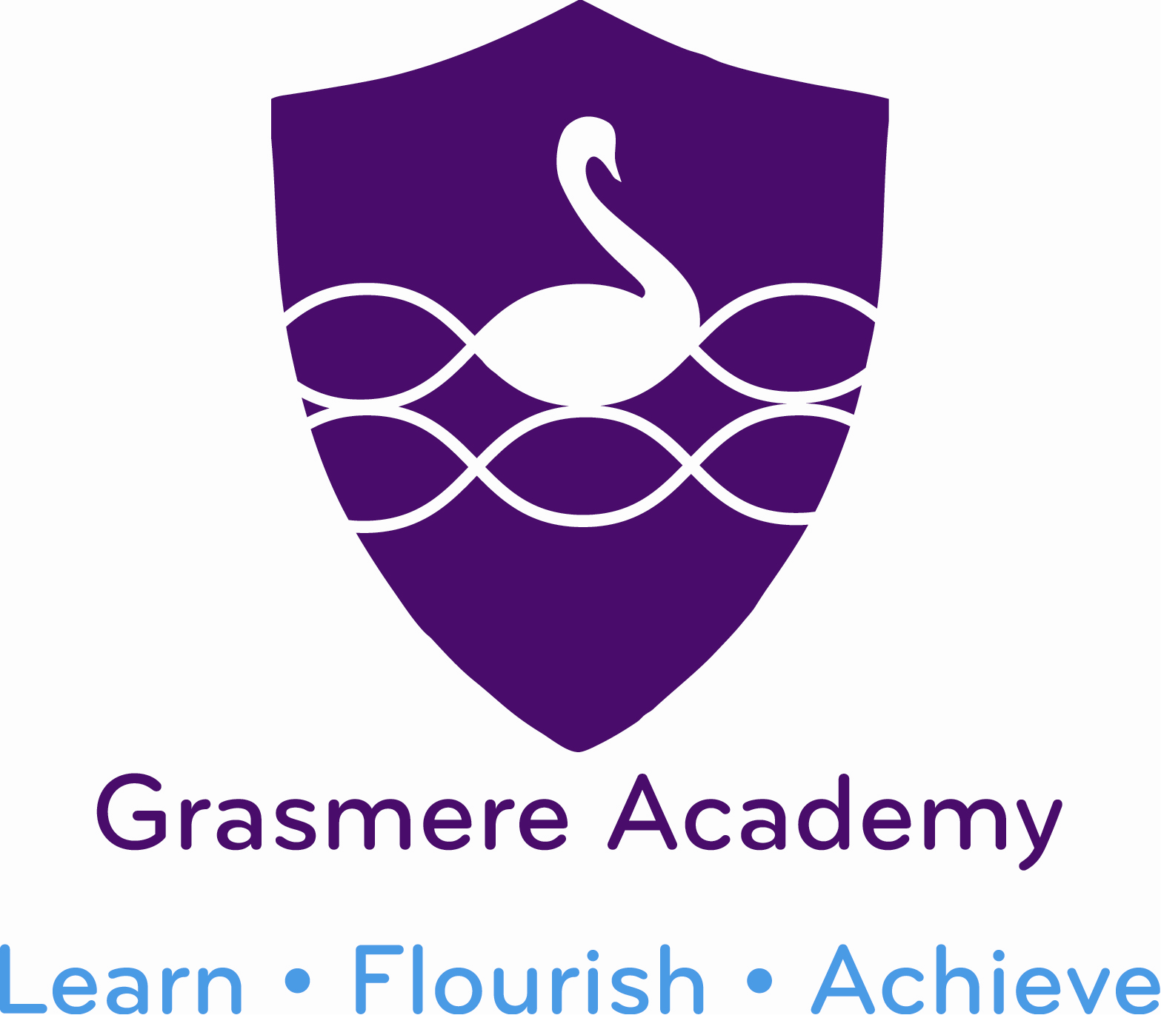
Year 6 Autumn 1 2020 Newsletter
twitter - @GrasmereSwans
‘How do we make our mark on the world?’
The team bubble… | Class teacher – Miss Witty  Assistant teacher – Mrs O’Donnell  PPA cover – Mrs Curry | Diary Dates  End of term  Friday 23rd October  Back to school  Monday 2nd November
Timings of the day | Start time: 9:00am  Home time: 3:05pm  It is very important that you drop off and collect your child on time so we can limit contact between class bubbles. When waiting on the yard please stand with your child on the lines. Children must not play on the yard with other children.
Things to remember… | Reading books will be sent home on a Tuesday and Friday. Please make sure you bring your reading folder to school on those days so staff can change your child’s books.  Please remember to bring a named water bottle to school everyday.  iPads need to come into school fully charged each day, however if you do not have a working charger at home, iPads can be charged at school.
P.E. day -  Tuesday | Please remember to come to school wearing your PE kit on this day. Named sand shoes/trainers, black shorts, white T-shirt and tracksuit bottoms and hoodie for outdoor sessions and colder days.  No jewellery to be worn on PE day this includes stud earrings.
Ready safe respectful | We will be launching our new school rules and behaviour system which focuses around the three words ‘Ready’ ‘Safe’ ‘Respectful’ . Children will continue to use the traffic lights in class and conversations around behaviour will focus on our 3 words and the zones of regulation bottles. Children who continue to display unsafe or disrespectful behaviour will be sent to reflection with Miss Girvan or Mrs Lilico and a slip sent home to parents/Carers.
Our project | Our project this term is all about making a positive impact on the world. We are going to be focusing on our wellbeing and strategies to improve our mental health. This will include creating calm boxes and coding a wellbeing game for children. We will be learning about strategies to help keep us calm in difficult situations. In literacy we will be looking at monologues, using positive and negative relationships to create our own. In class we will be reading the book ‘Wonder’ by R.J Palacio.
How can we help you… | Due to covid 19 restrictions we have to limit face to face contact between staff and parents. If you have any problems or concerns please do not hesitate to email me (michelle.witty@ntlp.org.uk) or call the school office on 0191 222 0259 to book a telephone conversation.
Home learning grids | We will be continuing our home learning on SeeSaw using the home learning grids. Please log into SeeSaw to see your child’s homework. If you require a paper copy please let staff know.
How to help your child… | Please listen to your child read, practise spellings and times tables and support with project home work.

